**Technical Memorandum 4.4: University Parking Lot Choice Model Development and OSU Model Calibration**

|  |  |
| --- | --- |
| **Prepared for:**  University Model Development Team |  |
| **Prepared by:**  Parsons Brinckerhoff  400 SW 6th Ave, Suite 802 Portland, Oregon 97204 | **PB Logo RGB.jpg** |

**June 2014 (Final Version)**

Table of Contents

[Introduction 4](#_Toc390158990)

[Parking Lot Data Processing 4](#_Toc390158991)

[Parking Lot Selection Data 4](#_Toc390158992)

[Parking Capacity 4](#_Toc390158993)

[Model Parking Lots 5](#_Toc390158996)

[Parking Location Choice Model General Description 7](#_Toc390158997)

[Parking Lot Choice Specification 7](#_Toc390158998)

[Simulation Model 8](#_Toc390158999)

[Shadow Price Calculation 8](#_Toc390159000)

[Tour Mode Choice Specification Changes 9](#_Toc390159001)

[OSU Model Calibration 10](#_Toc390159002)

[Student Residential Location Choice Model 10](#_Toc390159003)

[Worker Location Choice Model 12](#_Toc390159004)

[Auto Ownership Model 13](#_Toc390159005)

[Parking Lot Choice 14](#_Toc390159006)

[Parking Lot Choice Model Results 14](#_Toc390159007)

[Parking Lot Choice Model Calibration 26](#_Toc390159008)

[Tour Mode Choice 28](#_Toc390159009)

[Trip Mode Choice 30](#_Toc390159010)

[Parking Lot Choice Model User’s Guide 34](#_Toc390159011)

[Input Files 34](#_Toc390159012)

[New and Modified Output Files 35](#_Toc390159013)

[Model Use Instructions 36](#_Toc390159014)

[Running the Model with Simulation 36](#_Toc390159015)

[Running the Model with Calibrated Shadow Prices 36](#_Toc390159016)

[Running a New Scenario without Calibrated Shadow Prices 36](#_Toc390159017)

Table of Tables

[Table 1: Calibration Constants for Student Residential Location Choice 10](#_Toc390159018)

[Table 2: Worker Location Choice Calibration Constants 12](#_Toc390159019)

[Table 3: Auto Ownership Calibration Targets and Constants 13](#_Toc390159020)

[Table 4: Parking Lot Choice Results – Faculty/Staff Spaces 26](#_Toc390159021)

[Table 5: Parking Lot Choice Results – Student Spaces 27](#_Toc390159022)

[Table 6: Parking Lot Choice Results – General Spaces 27](#_Toc390159023)

[Table 7: Student Tour Mode Choice Calibration Targets 28](#_Toc390159024)

[Table 8: Faculty/Staff Tour Mode Choice Calibration Targets 29](#_Toc390159025)

[Table 9: Student Tour Mode Choice Calibration Constants 29](#_Toc390159026)

[Table 10: Faculty/Staff Tour Mode Choice Calibration Constants 29](#_Toc390159027)

[Table 11: Absolute Difference in Student Tour Mode Shares 30](#_Toc390159028)

[Table 12: Absolute Difference in Faculty/Staff Tour Mode Shares 30](#_Toc390159029)

[Table 13: Student University Tour Trip Mode Choice Calibration Targets 31](#_Toc390159030)

[Table 14: Student Non-University Tour Trip Mode Choice Calibration Targets 31](#_Toc390159031)

[Table 15: Faculty/Staff Work Tour Trip Mode Choice Calibration Targets 31](#_Toc390159032)

[Table 16: Student University Tour Trip Mode Choice Calibration Constants 32](#_Toc390159033)

[Table 17: Student Non-University Tour Trip Mode Choice Calibration Constants 32](#_Toc390159034)

[Table 18: Faculty/Staff Work Tour Trip Mode Choice Calibration Constants 32](#_Toc390159035)

[Table 19: Student University Tour Absolute Difference in Trip Mode Shares 32](#_Toc390159036)

[Table 20: Student Non-University Tour Absolute Difference in Trip Mode Shares 33](#_Toc390159037)

[Table 21: Faculty/Staff Work Tour Absolute Difference in Trip Mode Shares 33](#_Toc390159038)

[Table 22: New Input Files 34](#_Toc390159039)

Table of Figures

[Figure 1: Map of Parking Lot Locations by Type 6](file:///G:\projects\LCOG_University\7_Document\Draft%20Tech%20Memo%204%204_V3.docx#_Toc390159040)

[Figure 2: Student Residential Location Choice Model Distance Frequency Distribution 12](file:///G:\projects\LCOG_University\7_Document\Draft%20Tech%20Memo%204%204_V3.docx#_Toc390159041)

[Figure 3: Faculty/Staff Residential Location Distance Frequency Distribution 13](file:///G:\projects\LCOG_University\7_Document\Draft%20Tech%20Memo%204%204_V3.docx#_Toc390159042)

[Figure 4: Auto Ownership Calibration Results 14](file:///G:\projects\LCOG_University\7_Document\Draft%20Tech%20Memo%204%204_V3.docx#_Toc390159043)

[Figure 5: Observed vs. Modeled Maximum Daily Parking Demand for All Space Types 15](file:///G:\projects\LCOG_University\7_Document\Draft%20Tech%20Memo%204%204_V3.docx#_Toc390159044)

[Figure 6: Modeled and Observed Maximum Parking Utilization by Zone 16](#_Toc390159045)

[Figure 7: Parking Utilization and Tour Destinations by Zone 17](#_Toc390159046)

[Figure 8: Parking Demand over Time for Zone 389 18](file:///G:\projects\LCOG_University\7_Document\Draft%20Tech%20Memo%204%204_V3.docx#_Toc390159047)

[Figure 9: Parking Demand for All Space Types at 6:00 am 19](file:///G:\projects\LCOG_University\7_Document\Draft%20Tech%20Memo%204%204_V3.docx#_Toc390159048)

[Figure 10: Parking Demand for All Space Types at 8:00 am 20](file:///G:\projects\LCOG_University\7_Document\Draft%20Tech%20Memo%204%204_V3.docx#_Toc390159049)

[Figure 11: Parking Demand for All Space Types at 11:00 am 21](file:///G:\projects\LCOG_University\7_Document\Draft%20Tech%20Memo%204%204_V3.docx#_Toc390159050)

[Figure 12: Parking Demand for All Space Types at 1:30 pm 22](file:///G:\projects\LCOG_University\7_Document\Draft%20Tech%20Memo%204%204_V3.docx#_Toc390159051)

[Figure 13: Parking Demand for All Space Types at 4:00 pm 23](file:///G:\projects\LCOG_University\7_Document\Draft%20Tech%20Memo%204%204_V3.docx#_Toc390159052)

[Figure 14: Parking Demand for All Space Types at 7:00 pm 24](file:///G:\projects\LCOG_University\7_Document\Draft%20Tech%20Memo%204%204_V3.docx#_Toc390159053)

[Figure 15: Parking Demand for All Space Types at 10:00 pm 25](file:///G:\projects\LCOG_University\7_Document\Draft%20Tech%20Memo%204%204_V3.docx#_Toc390159054)

# Introduction

This memorandum describes the development of a parking lot location choice model component of the Major University Travel Model developed for the Oregon Department of Transportation. The University Travel Model was originally developed for the University of Oregon, and subsequently extended to forecast student and faculty/staff travel at Oregon State University (OSU). Parking on the OSU campus is limited for both students and faculty/staff, and many of the parking lots are already near capacity. The purpose of this work was to develop a tool to forecast parking lot usage on campus based on the available parking capacity data and the parking choice information provided in the Oregon State University travel survey. The final model includes a simulation-based time-dependent parking lot choice component which ensures that vehicle demand does not exceed available capacity at each lot.

# Parking Lot Data Processing

Data used to develop the parking location choice model came from three sources: the Oregon State University Travel Survey, the Parking Utilization Study, and estimates of off-campus residential roadway miles.

## Parking Lot Selection Data

Analysis of the data from the OSU student travel survey showed that the selection of the parking lot was based not only on the distance from the lot to the on-campus destination but also on the amount and type of parking available. The data showed that only 14% of students chose the lot closest to their on-campus destination. The remaining 86% of students parking chose to park in lots that were further away but larger for the most part. Based on the fact that the closest lot was not always the one selected, the parking lot model was formulated with multiple variables, including the total lot capacity, in order to draw students to the larger lots as was seen in the survey data.

## Parking Capacity

The parking model was formulated to use the parking capacity in two ways: 1) as a size term to attract students and faculty/staff to larger parking lots and 2) to identify the number of available spaces by the type of space (faculty/staff permit only, student permit only, and general) in order to assign demand for each market segment to the correct type of parking space.

### On-Campus Parking

The capacity of the on-campus parking lots was taken from the 2011-2012 OSU Parking Utilization Study. The study provided the parking utilization and capacity for all OSU-owned lots in 10 parking categories: Staff, Student, ADA, ADA Van, ADA Wheelchair, Reserved, Visitor, Metered, Free, and Motorcycle. The number of available spots in each lot based on these data was used to create space-type lot capacities for faculty/staff permit, student permit, and general spaces.

In order to simplify the modeling procedure, the lots were mapped to the TAZ in which they are located so that parking could be modeled at a TAZ level rather than an individual lot level. Using TAZs simplifies the calculations and allows for a more aggregate way to assign parking. All distance and travel time calculations are performed at the TAZ level using travel time and distance skims from the CALM model. In order to maintain the same level of spatial detail, the parking lot model was also applied at the TAZ level in the final implementation. The combination of space type and TAZ was used to define each lot in the model, and capacities are provided for each space type in each TAZ.

### Off-Campus Parking

In addition to the on-campus parking lots, the OSU Student Travel Survey also included responses from students parking on off-campus residential streets. Approximately 30% of students reporting parking on or near campus reported parking on a street in the off-campus region, while only 16% of driving faculty/staff parked in informal off-campus parking. In order to estimate a capacity for these off-campus locations, a rough estimate of the street miles in each zone was used. The street miles were then converted to potential parking spots using an estimate of 20 feet per vehicle. Instead of doubling those capacities to account for parking along both sides of the street, the capacities were left as the roadway length divided by 20 feet to account for the fact that in residential areas approximately half of the roadway is taken up by driveways that do not allow parking. The parking capacities generated in off-campus TAZs were classified as “general” space types and the TAZs were labeled as “Informal” parking.

A halo of TAZs surrounding the campus area were used as informal parking and added to the parking capacity input file. If additional capacity is required to accommodate the demand for off-campus parking in other scenarios, more zones can be added to the parking capacity file. This is especially applicable where off-campus zones are at capacity and additional zones nearby may provide the necessary spaces needed to meet the demand.

## Model Parking Lots

The set of zones with formal and informal parking in the OSU region are shown in Figure 1. On-campus lots are highlighted in green, and off-campus informal parking is shown in blue. Lots on campus that have no color did not have any OSU-owned parking lots with capacities provided in the OSU Parking Utilization Study or only had private lots that are not open to OSU students or faculty/staff. Off-campus zones with no color indicate that the zone is not included in the current set of parking capacity inputs. If required for future testing, an approximate capacity for these zones can be calculated and added to the input files.

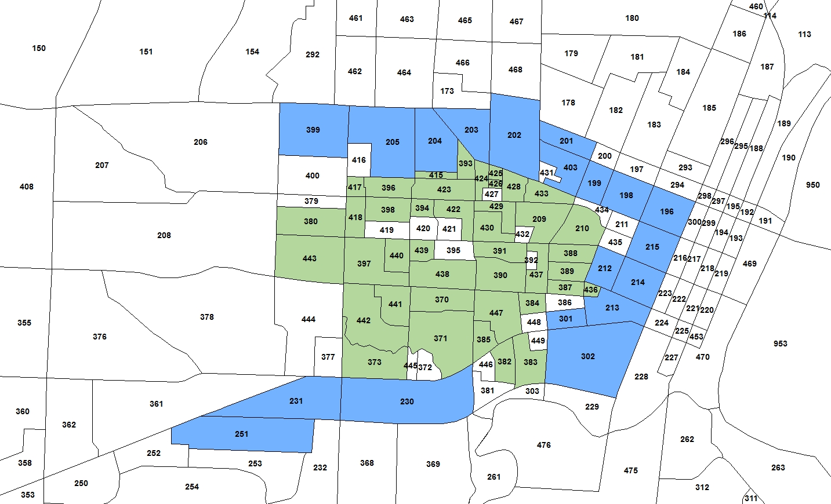

Figure : Map of Parking Lot Locations by Type

# Parking Location Choice Model General Description

The parking lot choice model was formulated so that the utility of the lot is dependent on the following variables:

* The utility of driving from the tour origin to the lot;
* The utility of walking or taking transit (such as a campus shuttle) from the lot to the on-campus destination;
* The size of the lot, which is a measurement of the potential parking opportunities; and,
* The expected availability of parking in the lot at the time of arrival, as measured by a shadow price which is explained in more detail below. This component is only used when the simulation is not used.
* A segment constant indicating for each segment which space type they are more or less likely to use. This constant is set to -999 for combinations of market segment and space type which are unavailable such as students and faculty/staff spaces.
* An informal constant used to calibrate the model to match the shares of OSU and informal parking for each market segment.
* The terminal time, which approximates the time required to get out of the parking lot, multiplied by twice the out-of-vehicle time coefficient in order to account for both leaving the car and going back to the car.

The parking lot choice model calculates the demand for each parking zone and space type as well as the shadow prices for the next iteration if the simulation model is not being used. The tour mode choice model takes into account parking availability and accessibility via a parking penalty term, which influences the utility of driving to campus. This is also explained in more detail below. If the simulation model is not used, the model is run iteratively until all lots are under capacity. If the simulation model is being used, the model is run twice, once with no demand inputs, and once with the demand from the first iteration used to calculate the parking penalty.

## Parking Lot Choice Specification

The utility of each parking lot in the parking location choice model is calculated based on the auto accessibility from the origin zone to the lot, the walk and walk to transit accessibilities from the lot to the destination, the shadow price, whether the lot is informal (on-street off-campus) parking, the availability of the lot to the person’s market segment, the terminal time for the lot, and the total number of spaces in the lot. The utility calculation is shown in Formula 1 below.

Equation 1: Parking Lot Utility Calculation

Where is the utility of lot L in time period t, is the SOV accessibility from origin O to lot L, is the walk accessibility from lot L to destination D, is a transit constant specified in the properties file, is the walk to transit accessibility from lot L to destination D, is the current shadow price for lot L during time period t, is a constant applied to informal parking, is a binary variable indicating whether the lot is informal parking, is the constant for lot L and market segment M, is the in-vehicle travel time coefficient from the Tour Mode Choice model, is the terminal time for lot L, and is the capacity of lot L. In this calculation each lot L is defined as a combination of TAZ and space type.

The tour origin, on-campus destination, time period, and market segment are properties of the tour that is using parking. The shadow prices, informal parking variable, and lot capacity are read in from input files, and the accessibilities are calculated within the code for the mode, lot, and destination provided. In the current implementation the walk to transit constant is set to -3.0 based on the share of parkers who utilize transit from the lot to their on-campus destination, and the informal parking constant is set to 0. The informal parking constants were calibrated to -1.1 for faculty/staff and -0.1 for students. The space type constants for faculty/staff parking were set to 0 for faculty/staff permit spaces, -3.0 for student permit spaces, and -5.0 for general parking spaces. The space type constants for students were set to -999 for faculty/staff permit spaces (since students aren’t allowed to park in those spaces), 0 for student permit spaces, and -5.0 for general parking spaces. The space type constants for visitors were set to -999 for faculty/staff permit spaces and student permit spaces and 0 for general parking spaces.

## Simulation Model

The parking location choice model can be set up to run with or without simulation. Without the simulation model, shadow prices are used to penalize lots that exceed their capacity, but many iterations are required to reach a point of convergence where all lots are below capacity. The simulation model, on the other hand, closes off lots when they become full, allowing all lots to be under capacity without using the shadow pricing mechanism.

The simulation model is run after the tour mode choice is complete, and it works by looping through each time period and assigning a parking zone (and parking demand) in that time period for SOV or HOV tours to campus. For each tour, the model checks if that tour starts in the time period being processed, and, if so, it checks if the tour is a student university tour or faculty/staff work tour using an auto mode. If all of those criteria are met, the model starts the parking lot selection process. The parking lot choice is the same as described already with the exception that if the simulation mode is used, a check is performed to ensure that only lots with available capacity are processed as possible lot choice options.

Once the simulation model selects a parking lot for a tour, the available capacity of that lot is decreased by the number of vehicles associated with the tour () from the tour start period until the tour end period to ensure that the entire time that the vehicle will be in that lot is accounted for. Once the demand in a lot exceeds its capacity for a given time period that lot becomes unavailable to any other tours in that period. This method ensures that the final demand is less than the capacity for all lots and more realistically models the actual choices where people arriving on campus after lots are full are forced to park in another lot.

## Shadow Price Calculation

The shadow price calculation penalizes lots based upon the number of parked vehicles at time t versus the total lot capacity. The shadow price is formulated to begin pricing lots when the demand is at 95% of supply, to reflect the expected disutility of searching for a parking space. The shadow price is also updated if the existing shadow price is negative but the lot does have demand. This allows the model to adjust large negative shadow prices calculated in early iterations of the model. The shadow pricing calculations work iteratively, adding to the previous shadow price at the end of each full model run. The formula for the shadow price calculation is shown below.

Equation 2: Parking Shadow Price Calculation

Where is the shadow price for lot L in time period t for market segment M, is the old shadow price for lot L in time period T, is the demand for lot L in time period T, and is the capacity of lot L.

The old shadow prices are read in from the ParkingShadowPrices.csv file in the model outputs folder. If there is no file in the outputs folder, the old shadow prices are set to 0. If the model is run in simulation mode, no shadow prices are calculated.

## Tour Mode Choice Specification Changes

The tour mode choice model was modified to account for the availability and utility of parking on campus for University tours and faculty/staff work tours, in order to reflect these variables in the utility of driving (and thereby affecting the probability of driving versus taking transit or non-motorized modes to the university). The auto mode utilities (SOV, HOV2, and HOV3+) were modified to include a parking penalty value. Therefore, if parking becomes less attractive because of increasingly restricted lot capacity or because only lots far away are available, auto utilities will decrease and alternative mode usage to campus will increase.

The parking location choice penalty reflects the expected attractiveness of parking across all lots for a given market segment and time period. The parking penalty is formulated to consider attractiveness of parking at all lots because it is theorized that the actual parking location may not be known a priori. In other words, someone who is contemplating driving to campus may not know exactly where they might park; they only have a general impression of the availability of parking. We expect this to particularly be the case for habitual transit users who may be less familiar with the parking system. For this reason, we prefer a term which takes into account the general utility of parking at all lots for their on-campus destination, rather than any one particular lot. The parking penalty is calculated as shown in Equation 3 and then applied to each auto mode utility (drive-alone, shared-ride 2, and shared-ride 3+). Note that the parking penalty calculation is specific to the person’s tour departure period.

Equation 3: Parking Penalty Calculation

Where is the parking penalty for time period t, is the walk accessibility from lot L to destination D, is a transit constant specified in the properties file, is the walk to transit accessibility from lot L to destination D, is the current shadow price for lot L during time period t, is a constant applied to informal parking, is a binary variable indicating whether the lot is informal parking, is the in-vehicle travel time coefficient from the Tour Mode Choice model, is the terminal time for lot L, and is the capacity of lot.

The auto modes are penalized if the walk and walk to transit accessibilities between the parking lots and the tour destination are low and if the shadow price is high, indicating that the lot is already at or near capacity. By penalizing auto modes where parking is not an attractive option for a tour to campus, the model is able to respond to parking limits not only by encouraging users to change to a different parking lot but also to change to a different mode in order to avoid parking.

If the simulation model is being used, the penalty calculation will first check to see if an existing parking demand file is located in the outputs folder. If a parking demand file is present, it is read in, and only lots that are below capacity at the time of the tour are included in the parking penalty calculation. This ensures that only lots relevant to the parking choice are included in the penalty, and if the only available lots are further from the tour destination, the choice of auto mode is penalized accordingly.

Due to the interactions between the tour mode choice and the parking lot choice model, if the simulation model is not used, the same set of shadow prices should be used in most iterations of the tour mode choice calibration. Once the calibration is nearly complete, the parking lot choice model results should be examined to determine if any adjustments are required. In the model implementation, it is recommended that final calibrated shadow prices be used in the initial iteration of the model. After each iteration, the lot demand should be investigated to determine whether any particular lot is over-capacity. If so, the entire model should be re-run with updated shadow prices, until all lots are at or below capacity.

# OSU Model Calibration

Only a subset of the model components developed for the university model were calibrated for the OSU inputs. The residential location choice models for both students and faculty/staff were calibrated to match the home locations provided in the OSU Travel Survey. Although the survey data could not be used to provide tour data, the home locations were able to provide an estimate of where students live that the model was calibrated to match. Additionally, the auto ownership and mode choice models were calibrated to match the targets from the University of Oregon Travel Survey data with the OSU population and the mode choices changes that resulted from the implementation of the parking lot choice model. The parking lot choice model was also run multiple times until the demand at all lots was below the capacity for all time periods.

## Student Residential Location Choice Model

The residential location model used in the student population synthesis for the University of Oregon was applied to the OSU model with small adjustments to calibration constants. The constants were adjusted in order to match the distribution of the share of students living within a given distance of the campus (represented by TAZ 422). Table 1 shows the final calibration targets used in the student residential location choice model for Oregon State University.

Table 1: Calibration Constants for Student Residential Location Choice

|  |  |
| --- | --- |
| **Distance Category** | **Calibration Constant** |
| 0 to 1 miles | -0.51044 |
| 1 to 2 miles | -0.14346 |

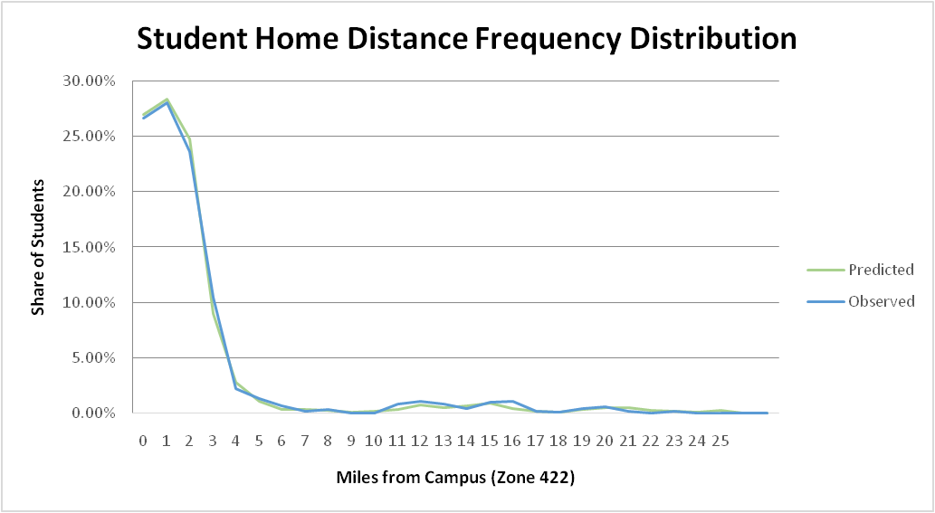

Figure 3 shows the frequency distribution of students’ distance from home to campus for OSU. The targets were taken from the student home locations provided in the OSU Student Travel Survey.

## Worker Location Choice Model

Figure : Student Residential Location Choice Model Distance Frequency Distribution

The faculty/staff residential location choice model implementation was the same as was used in the University of Oregon model, but calibration constants specific to the Oregon State region were estimated to better match the residential distribution of faculty/staff workers. The final calibration constants used in the worker location choice model are shown in Table 2.

Table 2: Worker Location Choice Calibration Constants

|  |  |
| --- | --- |
| **Distance Category** | **Calibration Constant** |
| 0 to 1 miles | 0.205346 |
| 1 to 2 miles | 0.32556 |
| 2 to 3 miles | -0.07318 |

Using these calibration constants, the worker location choice model was implemented, and the distance frequency distribution of the distance from the worker home location to the university reference TAZ from the model and survey were compared. Figure 4 shows the distance frequency distribution for the worker residential location choice model. The model closely matches the survey data for most distance categories with a slightly higher share of predicted workers approximately 15-17 miles from campus. This discrepancy was allowed to remain in the model output based on survey bias that may have caused the home locations further away from campus to be under-represented in the survey responses.

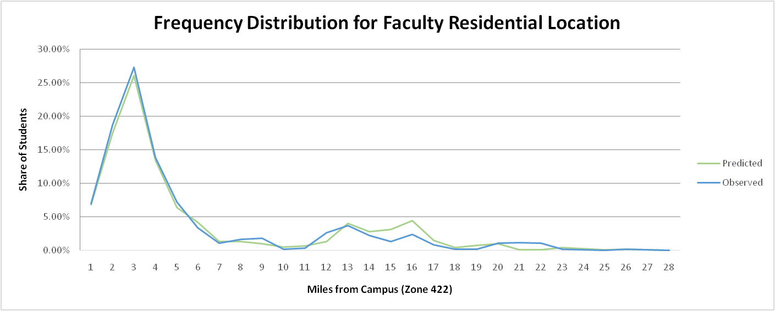

Figure : Faculty/Staff Residential Location Distance Frequency Distribution

## Auto Ownership Model

The auto ownership model calibration was crucial to ensuring that the other model elements were able to achieve the correct results. The auto ownership affects the modes that are available to a person, and the mode choice affects the decision of whether the tour will use a parking lot. Therefore, the auto ownership calibration was performed prior to the parking lot choice and tour mode choice calibration. The targets and final calibration constants for auto ownership model for each market (Group Quarters Student, Off-Campus Non-Family Student, Off-Campus Family Student, and Faculty/Staff) are shown in Table 3.

Table 3: Auto Ownership Calibration Targets and Constants

|  |  |  |  |
| --- | --- | --- | --- |
| **Market Segment** | **No-Auto Target Share** | **Auto Owned Target Share** | **No-Auto Calibration Constant** |
| Group Quarters | 53.9% | 46.1% | -0.3260 |
| Off-Campus Non-Family | 27.3% | 72.7% | -0.2748 |
| Off-Campus Family | 15.0% | 85.0% | -0.0143 |
| Faculty/Staff | 6.0% | 94.0% | -0.8413 |

Faculty/Staff had the highest level of auto ownership at 94%, and Group Quarters Students had the lowest at 46.1%. The calibration targets were generated from the University of Oregon Travel Survey due to the lack of data regarding auto ownership in the Oregon State University Travel Survey. The final auto ownership calibration results are shown in Figure 5. The auto ownership levels were matched for all market segments at the end of the calibration process.

## Parking Lot Choice

Figure : Auto Ownership Calibration Results

The parking lot choice model calibration was performed using the simulation model. The simulation allows for the parking lot choice model to be run with only two iterations and provides results where all lots are at or under capacity. Two iterations of the parking lot choice simulation model were run. The first provided demand with no inputs, and the second used the parking demand from the first iteration to update the parking penalties and adjust the tour mode choice results. The results shown are from the second iteration of the parking location choice model with simulation.

### Parking Lot Choice Model Results

The parking lot choice model was able to match the observed demand closely for most lots. There were some outliers, most notably student parking in TAZ 447 where the large parking garage was only modeled to have a maximum demand approximately 2/3 of the maximum observed demand. Overall, however, the final parking lot demand matched the observed demand well. Figure 5 shows a comparison of the observed versus modeled maximum daily demand across all space types. Across all space types and lots, the model generally predicted slightly lower maximum daily demand than the observed data.

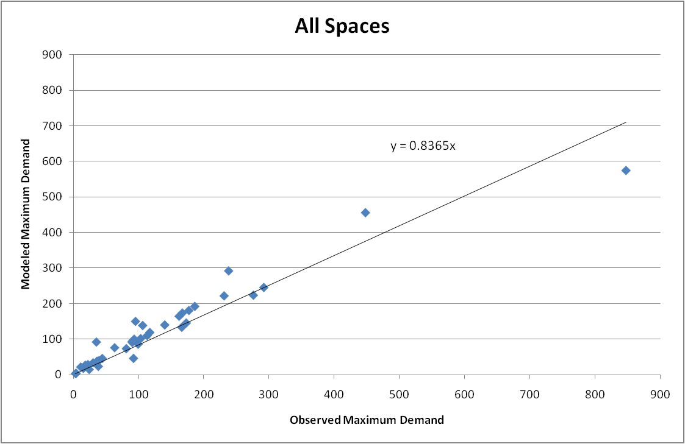A comparison of the modeled and observed maximum utilization (demand/capacity) at each lot also shows that the spatial distribution of parking is generally matching the observed data. Figure 6 shows a map of maximum modeled and observed utilization by TAZ for all space types. Zones colored blue are off-campus informal parking zones, and they did not have any observed parking data.

Figure : Observed vs. Modeled Maximum Daily Parking Demand for All Space Types

By comparing the parking demand to the number of tours in a zone we can also observe how closely the parking levels and tour levels match by zone. Figure 7 shows a map with the number of tours in each zone as well as the parking utilization. The high parking lot utilization in the northern region of campus corresponds to a high number of tours in that region. The more southern lots have low utilization levels, and they also have a lower number of tours destined for each zone. This seems to indicate that while users may not park in the exact zone where their tour destination is, the general patterns of parking and tour destinations do match.

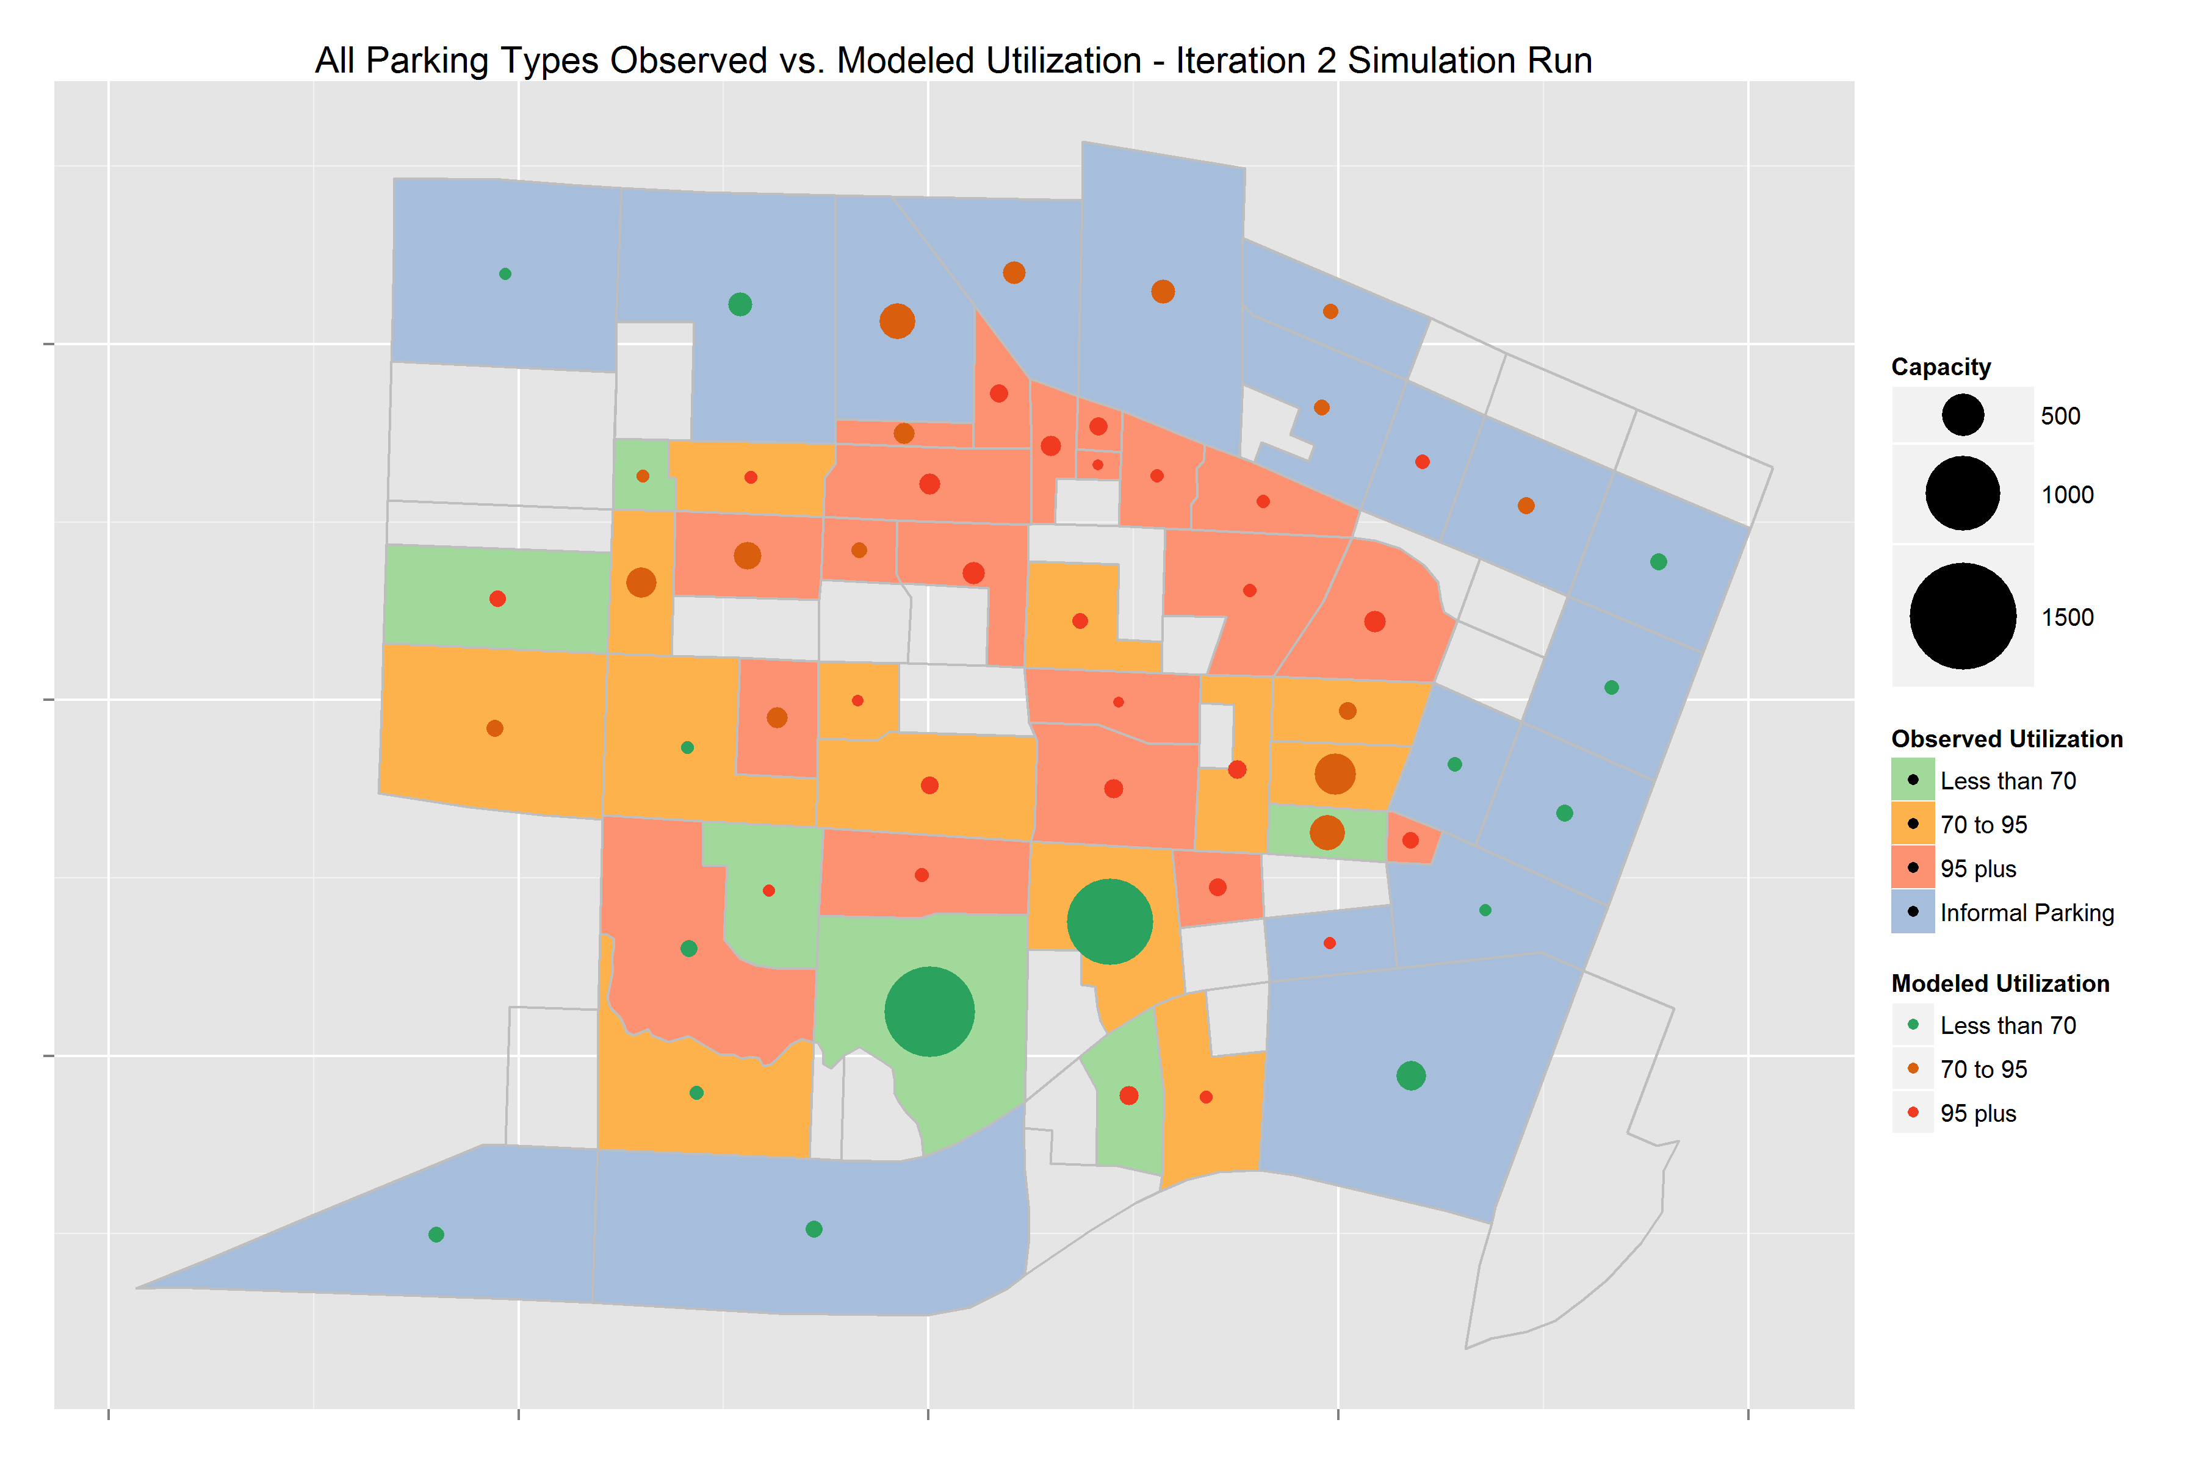

Figure : Modeled and Observed Maximum Parking Utilization by Zone

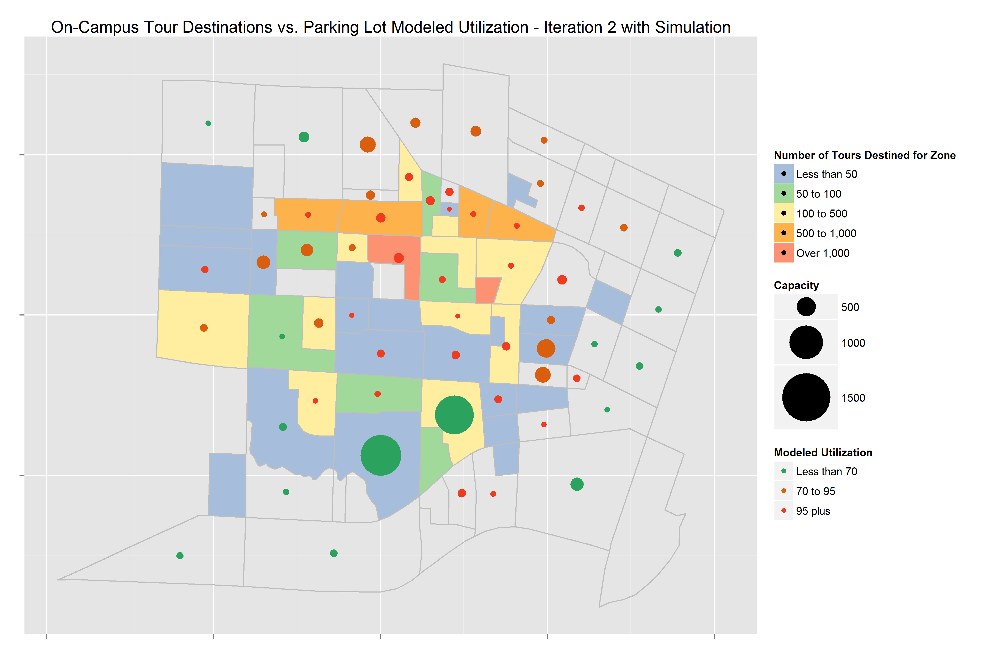

Figure : Parking Utilization and Tour Destinations by Zone

In addition to spatial distribution of parking demand, the temporal distribution also provides some insight into the parking behavior. Figure 8 shows a graph of the parking demand and capacity of zone 389, which has both faculty/staff and student permit spaces. The demand for faculty/staff spaces increases between 6 am and 8 am and then remains steady throughout most of the day, tapering off sharply between 5 pm and 9 pm. The demand for student permit spots, on the other hand, shows a second peak in parking in the early afternoon and tapers off much more slowly from 5 pm to midnight.

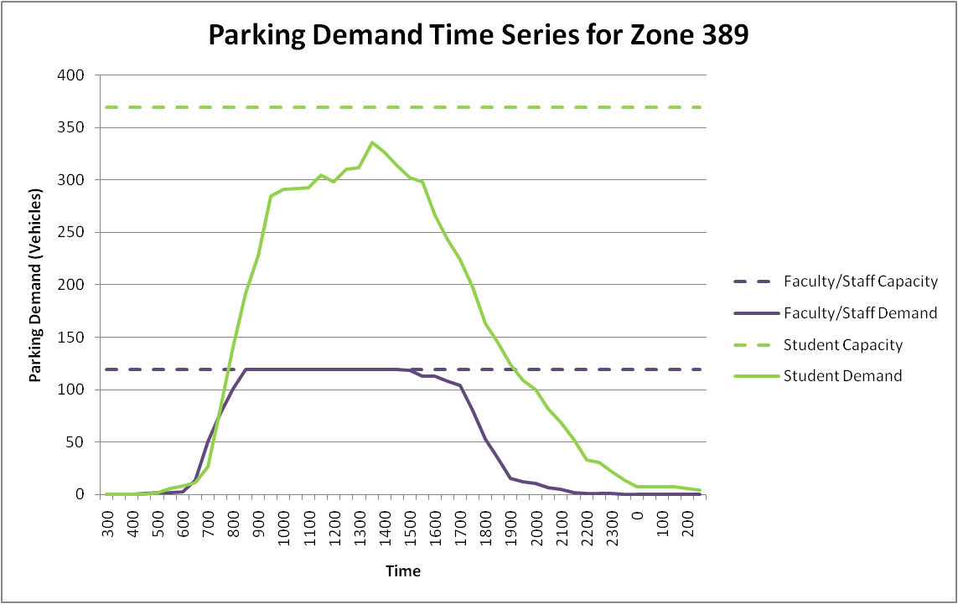A series of maps showing parking demand over time for all space types is also provided in Figure 9 to Figure 15. In these maps, the size of the dot in each zone indicates the amount of parking demand during that time period, and the color of the zone shows the level of parking utilization. At 6 am there is very little demand, but there are a few vehicles parking on campus already, spread out across the campus area as well as the off-campus zones. By 8 am the parking demand greatly increases, and some zones are already at 95% or more of their capacity. By 11 am most of the northern lots are full, and the off-campus zones are starting to fill up as well. At 1:30 pm, the time with the highest parking demand, many of the informal parking zones north of campus are at 70% to 95% of capacity, and the on-campus zones in the northern area of campus are also very highly utilized. By 4 pm most of the off-campus informal parking zones have dropped to a utilization of less than 70% and most of the on-campus zones that were previously at over 95% utilization drop to a lower utilization rate. At 7 pm all lots are at less than 70% utilization, and only a small number of lots still have more than 100 vehicles of demand. At 10 pm most of the vehicles have left, and there is only a very small amount of demand in any of the on-campus or off-campus zones.

Figure : Parking Demand over Time for Zone 389

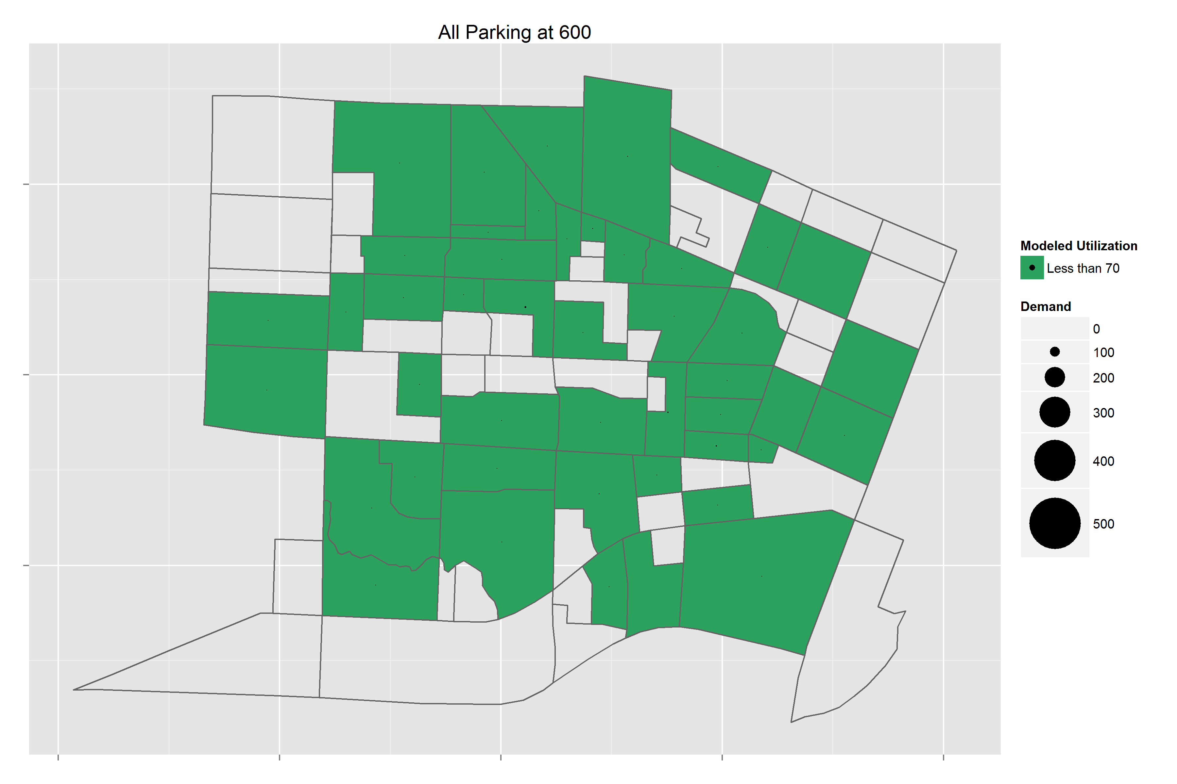

Figure : Parking Demand for All Space Types at 6:00 am

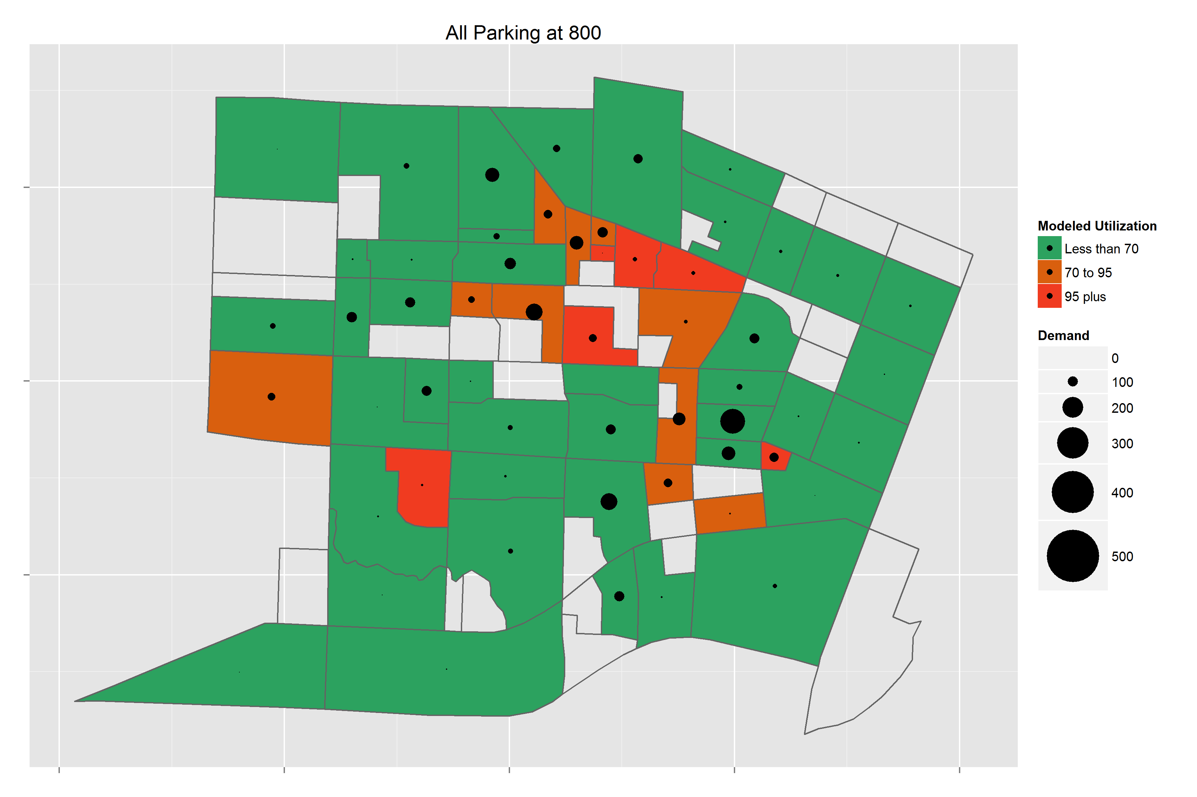

Figure : Parking Demand for All Space Types at 8:00 am

### All_Time1100.png

Figure : Parking Demand for All Space Types at 11:00 am

### All_Time1330.png

Figure : Parking Demand for All Space Types at 1:30 pm

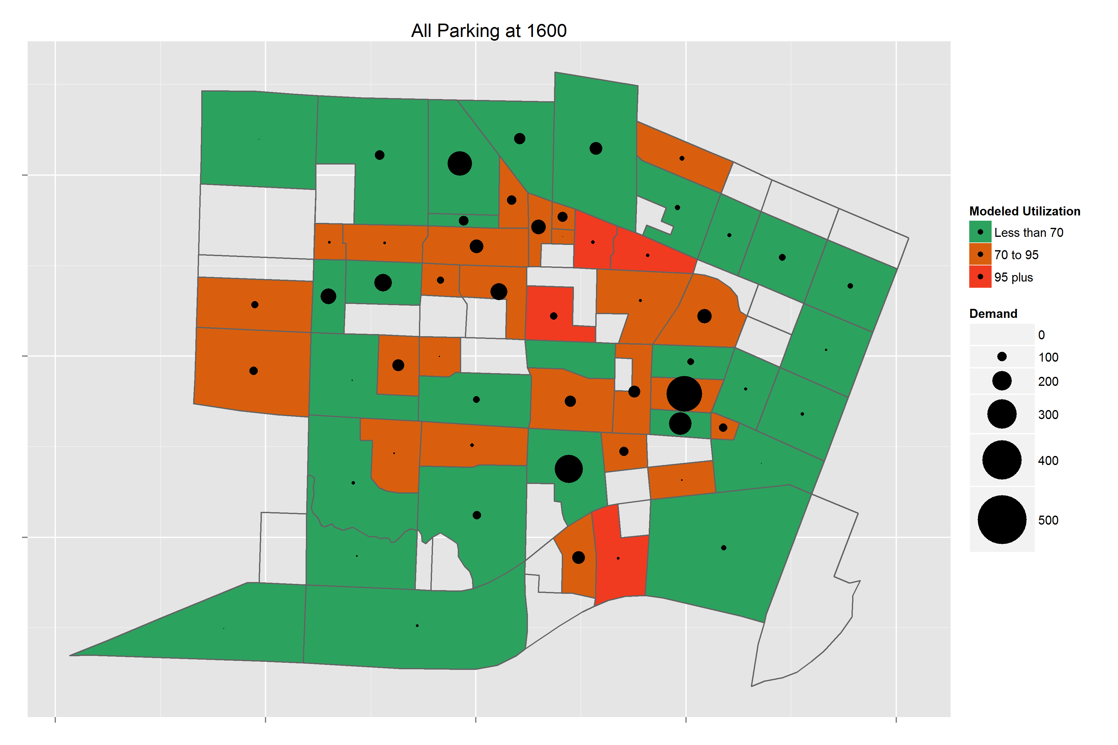

Figure : Parking Demand for All Space Types at 4:00 pm

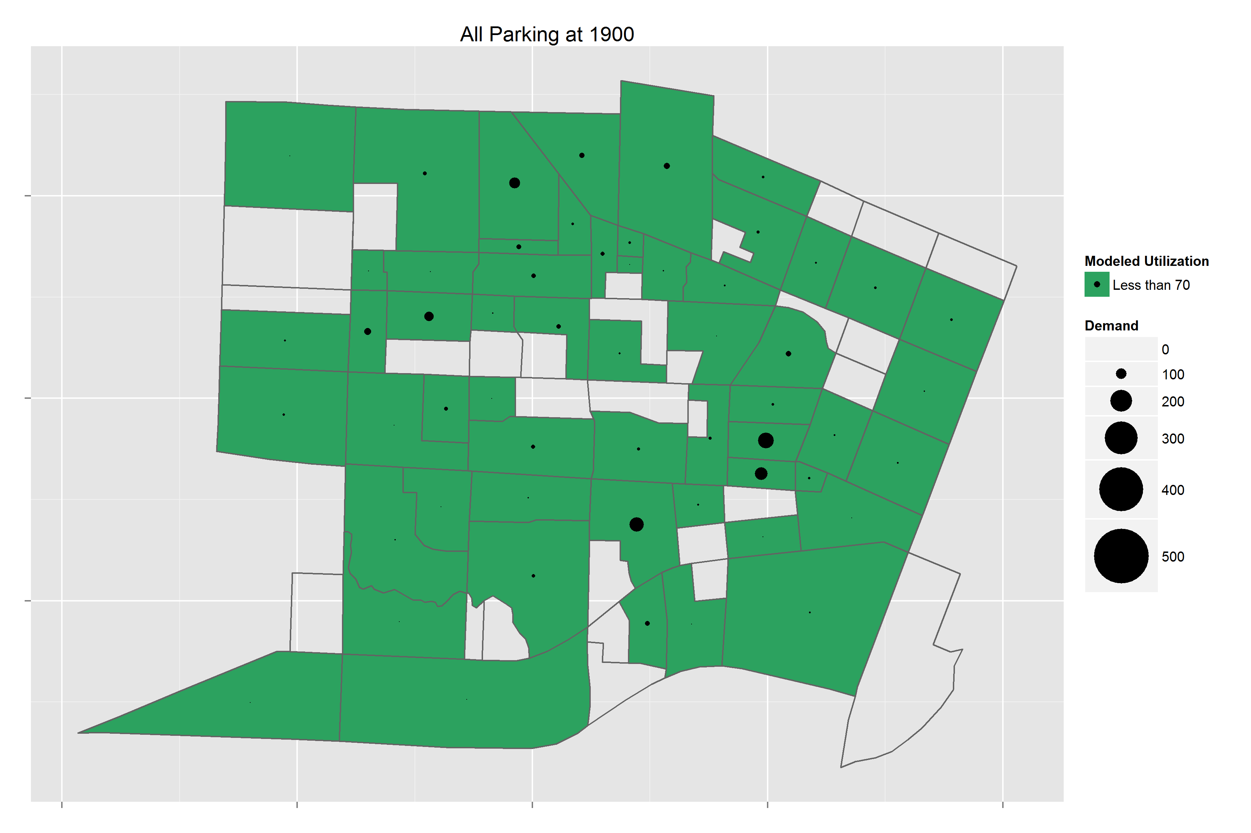

Figure : Parking Demand for All Space Types at 7:00 pm

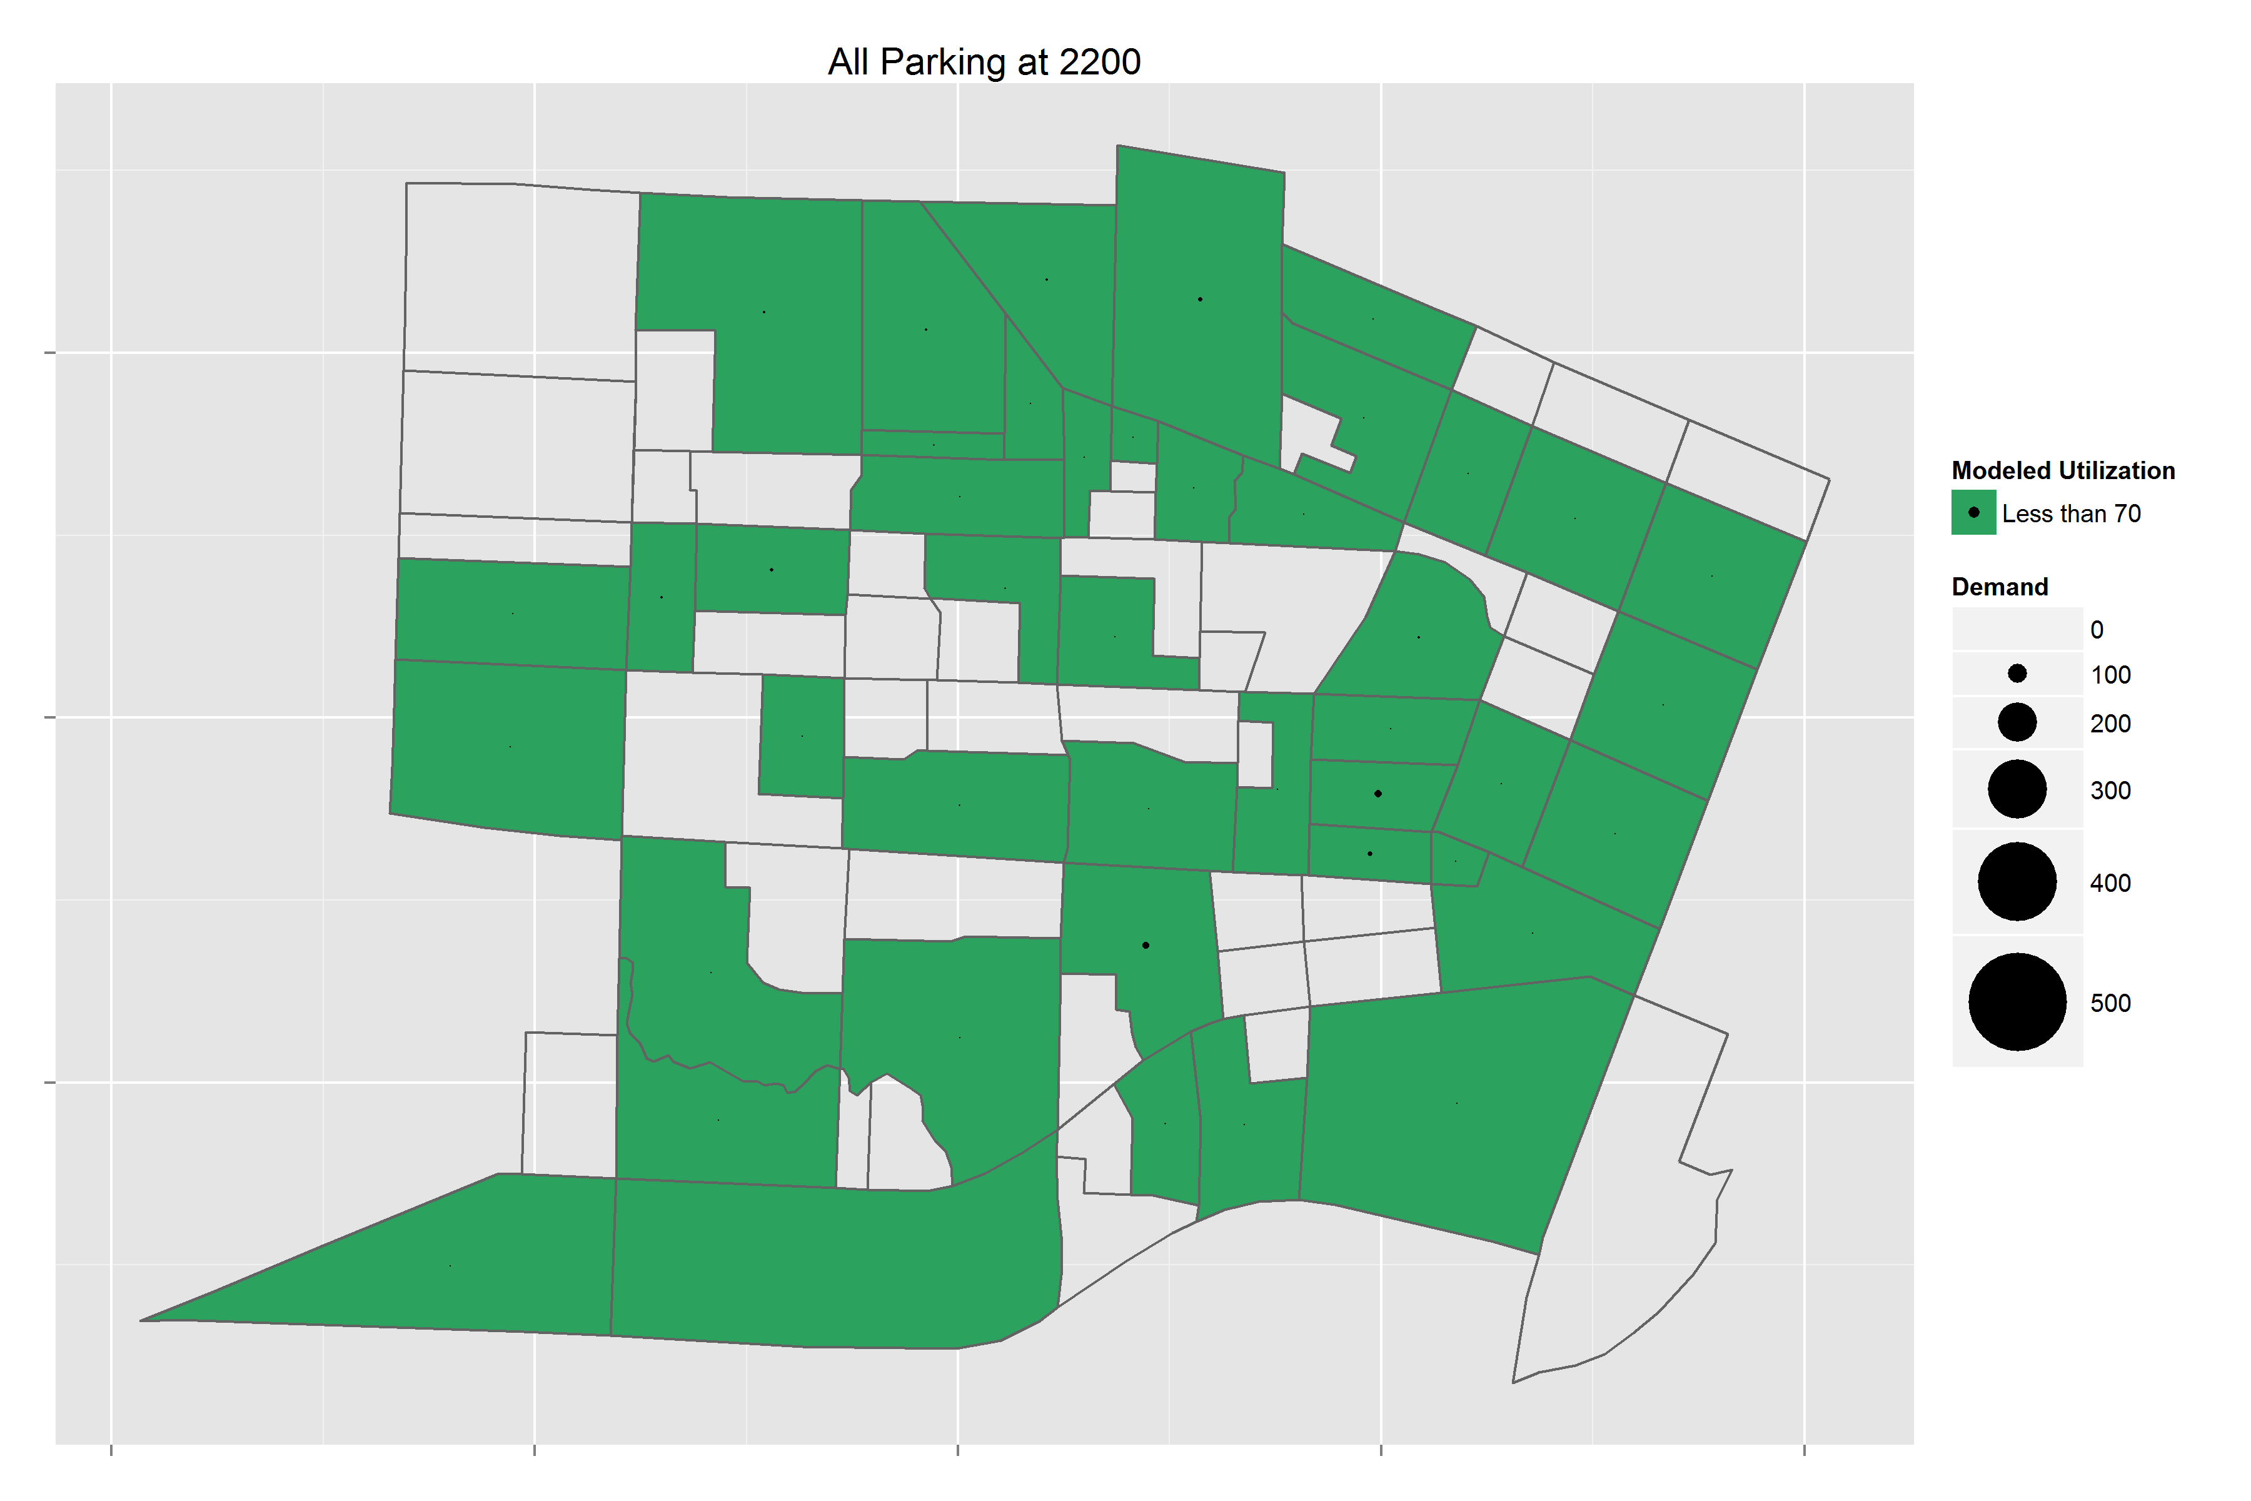

Figure : Parking Demand for All Space Types at 10:00 pm

### Parking Lot Choice Model Calibration

The final calibrated parking lot choice model results are summarized in Table 4 and Table 5. The parking lot choice model resulted in a demand where no lot exceeds its total capacity, and some lots remained well under capacity even at the peak. Table 4 summarizes the parking demand data for faculty/staff spaces with a field indicating whether the parking in each zone is informal street parking, the capacity, and the maximum demand and when it occurs. Table 5 shows the same data for student spaces, and Table 6 shows the same set of data for general parking spaces.

Table 4: Parking Lot Choice Results – Faculty/Staff Spaces

|  |  |  |  |  |  |
| --- | --- | --- | --- | --- | --- |
| **Parking Zone** | **Street Parking** | **Capacity** | **Maximum Observed Demand** | **Maximum Modeled Demand** | **Max Demand Time (Model)** |
| 424 | No | 164 | 162 | 164 | 8:30 |
| 422 | No | 139 | 137 | 140 | 7:30 |
| 389 | No | 119 | 116 | 120 | 12:30 |
| 425 | No | 118 | 117 | 119 | 11:30 |
| 393 | No | 113 | 113 | 110 | 12:30 |
| 440 | No | 113 | 113 | 105 | 13:00 |
| 418 | No | 107 | 86 | 89 | 11:30 |
| 437 | No | 105 | 100 | 106 | 8:30 |
| 423 | No | 97 | 97 | 97 | 13:00 |
| 371 | No | 93 | 76 | 24 | 9:30 |
| 394 | No | 81 | 81 | 73 | 12:30 |
| 384 | No | 68 | 68 | 66 | 12:30 |
| 390 | No | 68 | 66 | 69 | 10:00 |
| 210 | No | 49 | 49 | 50 | 10:30 |
| 447 | No | 49 | 49 | 35 | 12:30 |
| 370 | No | 45 | 44 | 46 | 13:00 |
| 398 | No | 39 | 38 | 40 | 13:00 |
| 428 | No | 39 | 39 | 40 | 8:30 |
| 209 | No | 37 | 36 | 38 | 8:30 |
| 433 | No | 37 | 36 | 38 | 10:00 |
| 417 | No | 34 | 18 | 27 | 11:30 |
| 397 | No | 28 | 24 | 15 | 9:00 |
| 396 | No | 27 | 26 | 28 | 13:00 |
| 388 | No | 22 | 22 | 23 | 10:00 |
| 443 | No | 16 | 8 | 8 | 10:30 |
| 439 | No | 13 | 13 | 13 | 13:00 |
| 438 | No | 10 | 8 | 10 | 8:30 |
| 426 | No | 4 | 4 | 4 | 8:00 |
| 391 | No | 3 | 3 | 3 | 8:00 |
| 424 | No | 164 | 162 | 164 | 8:30 |
| 422 | No | 139 | 137 | 140 | 7:30 |
| 389 | No | 119 | 116 | 120 | 12:30 |
| 425 | No | 118 | 117 | 119 | 11:30 |

Table 5: Parking Lot Choice Results – Student Spaces

|  |  |  |  |  |  |
| --- | --- | --- | --- | --- | --- |
| **Parking Zone** | **Street Parking** | **Capacity** | **Maximum Observed Demand** | **Maximum Modeled Demand** | **Max Demand Time (Model)** |
| 447 | No | 1,123 | 794 | 531 | 13:30 |
| 371 | No | 1,118 | 203 | 205 | 13:30 |
| 387 | No | 385 | 237 | 288 | 13:30 |
| 389 | No | 369 | 332 | 336 | 13:30 |
| 398 | No | 241 | 237 | 184 | 13:30 |
| 418 | No | 203 | 145 | 133 | 13:30 |
| 415 | No | 171 | 166 | 133 | 13:30 |
| 210 | No | 123 | 123 | 124 | 13:00 |
| 442 | No | 94 | 92 | 46 | 11:30 |
| 438 | No | 81 | 81 | 75 | 13:30 |
| 388 | No | 77 | 77 | 55 | 11:30 |
| 423 | No | 76 | 70 | 76 | 13:30 |
| 440 | No | 60 | 60 | 41 | 11:30 |
| 373 | No | 53 | 38 | 23 | 12:30 |
| 422 | No | 51 | 49 | 51 | 11:30 |
| 390 | No | 46 | 46 | 37 | 13:30 |
| 396 | No | 6 | 4 | 6 | 9:30 |

Table : Parking Lot Choice Results – General Spaces

|  |  |  |  |  |  |
| --- | --- | --- | --- | --- | --- |
| **Parking Zone** | **Street Parking** | **Capacity** | **Maximum Observed Demand** | **Maximum Modeled Demand** | **Max Demand Time (Model)** |
| 382 | No | 149 | 95 | 150 | 13:00 |
| 380 | No | 91 | 35 | 92 | 9:30 |
| 436 | No | 90 | 90 | 91 | 8:30 |
| 443 | No | 85 | 82 | 86 | 9:30 |
| 430 | No | 75 | 63 | 76 | 8:00 |
| 384 | No | 35 | 35 | 36 | 8:30 |
| 390 | No | 33 | 28 | 34 | 8:00 |
| 437 | No | 32 | 6 | 33 | 12:30 |
| 371 | No | 31 | 13 | 16 | 13:30 |
| 383 | No | 28 | 22 | 28 | 8:30 |
| 441 | No | 21 | 11 | 22 | 8:30 |
| 438 | No | 14 | 4 | 15 | 10:30 |
| 388 | No | 8 | 0 | 8 | 8:00 |
| 447 | No | 8 | 5 | 8 | 8:30 |
| 210 | No | 6 | 5 | 7 | 8:30 |
| 439 | No | 4 | 2 | 4 | 12:00 |
| 387 | No | 3 | 1 | 4 | 8:00 |
| 422 | No | 1 | 0 | 1 | 6:00 |
| 204 | Yes | 400 | n.a. | 365 | 13:30 |
| 302 | Yes | 300 | n.a. | 80 | 12:30 |
| 202 | Yes | 220 | n.a. | 187 | 13:30 |
| 205 | Yes | 220 | n.a. | 144 | 13:30 |
| 203 | Yes | 200 | n.a. | 179 | 13:00 |
| 196 | Yes | 100 | n.a. | 62 | 12:00 |
| 198 | Yes | 100 | n.a. | 86 | 13:30 |
| 214 | Yes | 100 | n.a. | 55 | 13:30 |
| 230 | Yes | 100 | n.a. | 35 | 10:30 |
| 231 | Yes | 80 | n.a. | 9 | 12:30 |
| 251 | Yes | 80 | n.a. | 15 | 12:30 |
| 403 | Yes | 80 | n.a. | 60 | 9:30 |
| 201 | Yes | 70 | n.a. | 64 | 13:30 |
| 199 | Yes | 60 | n.a. | 60 | 11:30 |
| 212 | Yes | 60 | n.a. | 31 | 14:00 |
| 215 | Yes | 60 | n.a. | 41 | 13:30 |
| 213 | Yes | 20 | n.a. | 7 | 9:30 |
| 301 | Yes | 20 | n.a. | 20 | 14:30 |
| 399 | Yes | 20 | n.a. | 6 | 11:30 |

Some of the demand values exceed the capacity by one vehicle as a result of rounding, but the simulation model ensured that no lot exceeded the capacity by more than a fractional amount. The maximum demand time shown is the first time period in which the demand was at the maximum value, but for many of these lots, especially the faculty/staff spaces, the demand remained at that maximum value for many hours after the time shown.

## Tour Mode Choice

The Tour Mode Choice model calibration results shown are from the second iteration of the model run with the simulation model used for parking lot choice. If the model was run without simulation, the tour mode choice constants would change as a result of the shadow prices being used in the parking penalty.

The Tour Mode Choice model was calibrated by tour purpose and auto ownership level for both faculty/staff and student tours. The calibration targets for student tours are shown in Table 7, and the calibration targets for faculty/staff tours are shown in Table 8. Unlike the University of Oregon model, the OSU regional model does not include premium transit, so only one general transit mode was included in the tour mode choice model.

Table 7: Student Tour Mode Choice Calibration Targets

|  |  |  |  |  |  |  |  |  |  |
| --- | --- | --- | --- | --- | --- | --- | --- | --- | --- |
| **Tour Mode** | **University** | | **Work** | | **Maintenance** | | **Discretionary** | | |
| **No Auto** | **Auto** | **No Auto** | **Auto** | **No Auto** | **Auto** | **No Auto** | **Auto** |
| Drive Alone | -- | 28.0% | -- | 33.7% | -- | 26.9% | -- | 20.9% |
| HOV2 | 0.5% | 9.1% | 2.8% | 9.0% | 21.9% | 42.2% | 23.0% | 34.2% |
| HOV3+ | 1.5% | 4.1% | 3.0% | 2.4% | -- | 5.3% | 1.7% | 3.3% |
| Walk | 52.0% | 22.5% | 52.4% | 23.3% | 29.8% | 13.9% | 51.7% | 31.7% |
| Bike | 34.9% | 28.9% | 33.5% | 26.9% | 21.9% | 7.5% | 4.9% | 7.3% |
| Transit | 11.1% | 7.4% | 8.3% | 4.7% | 26.4% | 4.2% | 18.8% | 2.6% |
| Total | 100% | 100% | 100% | 100% | 100% | 100% | 100% | 100% |

Table 8: Faculty/Staff Tour Mode Choice Calibration Targets

|  |  |  |  |
| --- | --- | --- | --- |
| **Tour Mode** | **Work** | | |
| **No Auto** | **Auto** |
| Drive Alone | -- | 55.9% |
| HOV2 | 7.7% | 10.6% |
| HOV3+ | 7.7% | 8.5% |
| Walk | 35.3% | 4.8% |
| Bike | 23.7% | 16.9% |
| Transit | 25.6% | 3.3% |
| Total | 100% | 100% |

Due to the fact that the tour frequency inputs were based on a different student population, the mode choice calibration was only used to match mode shares, not total tours. The final mode choice calibration constants for student tours are shown in Table 9, and the final mode choice calibration constants for faculty/staff tours are shown in Table 10.

Table 9: Student Tour Mode Choice Calibration Constants

|  |  |  |  |  |  |  |  |  |  |
| --- | --- | --- | --- | --- | --- | --- | --- | --- | --- |
| **Tour Mode** | **University** | | **Work** | | **Maintenance** | | **Discretionary** | | |
| **No Auto** | **Auto** | **No Auto** | **Auto** | **No Auto** | **Auto** | **No Auto** | **Auto** |
| Drive Alone | 0 | 0 | 0 | 0 | 0 | 0 | 0 | 0 |
| HOV2 | 0 | -0.2574 | 0 | -0.4944 | 0 | 0.4015 | 0 | 0.4889 |
| HOV3+ | 2.2278 | 1.1696 | 1.4133 | 0.1229 | -999 | 0.9979 | -0.1886 | 0.8888 |
| Walk | 3.8305 | -0.2256 | 4.1079 | 2.1537 | 0.8434 | 0.5017 | 0.5809 | 1.5173 |
| Bike | 2.9520 | -0.6493 | 2.6555 | 1.3870 | 0.3275 | -0.0484 | -1.0188 | 0.3651 |
| Transit | 5.1072 | 1.3784 | 4.6493 | 3.5665 | 3.4887 | 2.6856 | 2.8393 | 2.9645 |

Table 10: Faculty/Staff Tour Mode Choice Calibration Constants

|  |  |  |  |
| --- | --- | --- | --- |
| **Tour Mode** | **Work** | | |
| **No Auto** | **Auto** |
| Drive Alone | 0 | 0 |
| HOV2 | 0 | -0.7517 |
| HOV3+ | 1.6436 | 0.8909 |
| Walk | 4.7701 | -0.7668 |
| Bike | 1.0172 | -1.5979 |
| Transit | 5.8781 | 0.8091 |

The calibration constants on student university tours and faculty/staff work tours are both smaller for the auto segment than the no auto segment. This is most likely a result of the parking penalty shifting tours away from auto modes, creating higher mode shares for non-auto modes without a larger calibration constant.

When the calibration constants were applied with the second iteration of the parking lot choice simulation model, the shares of all tour modes are within 3% of the target shares for both student faculty/staff tours. The absolute differences in tour mode shares for student tours are shown in Table 11, and the absolute differences in tour mode shares for faculty/staff tours are shown in Table 12.

Table 11: Absolute Difference in Student Tour Mode Shares

|  |  |  |  |  |  |  |  |  |
| --- | --- | --- | --- | --- | --- | --- | --- | --- |
| **Tour Mode** | **University** | | **Work** | | **Maintenance** | | **Discretionary** | |
| **No Auto** | **Auto** | **No Auto** | **Auto** | **No Auto** | **Auto** | **No Auto** | **Auto** |
| Drive Alone | 0.0% | -1.0% | 0.0% | 0.5% | 0.0% | -0.2% | 0.0% | -0.4% |
| HOV2 | -0.2% | -0.1% | 0.6% | 1.8% | -0.2% | 1.0% | 2.1% | 0.7% |
| HOV3+ | -0.3% | -0.4% | -0.6% | -1.1% | 0.0% | -0.1% | -1.0% | 0.5% |
| Walk | 0.3% | 1.3% | 0.3% | -1.0% | 0.7% | -0.3% | -0.5% | -0.2% |
| Bike | 0.2% | -0.1% | -0.3% | 0.7% | 0.8% | 0.1% | -0.6% | -0.4% |
| Transit | -0.1% | 0.3% | 0.0% | -0.9% | -1.3% | -0.6% | 0.0% | -0.2% |
| Total | 0.0% | 0.0% | 0.0% | 0.0% | 0.0% | 0.0% | 0.0% | 0.0% |

Table 12: Absolute Difference in Faculty/Staff Tour Mode Shares

|  |  |  |  |
| --- | --- | --- | --- |
| **Tour Mode** | **Work** | | |
| **No Auto** | **Auto** |
| Drive Alone | 0.0% | 1.7% |
| HOV2 | 2.8% | -0.5% |
| HOV3+ | 2.1% | 0.8% |
| Walk | -1.7% | -0.4% |
| Bike | -0.6% | -1.5% |
| Transit | -2.6% | -0.1% |
| Total | 0.0% | 0.0% |

## Trip Mode Choice

After the Tour Mode Choice calibration was completed, the Trip Mode Choice Model was calibrated using the second iteration of simulation results. The Trip Mode Choice Model was calibrated for students by university and non-university tours and for faculty/staff for work tours. Due to the lack of trip data in the Oregon State University travel survey, the calibration targets were derived from the University of Oregon model, so only mode shares and comparison of mode shares are shown here due to the fact that total trips do not match. The trip mode choice calibration targets for student university tours are shown in Table 13, and the calibration targets for student non-university tours are shown in Table 14. The calibration targets for faculty/staff work tours are shown in Table 15. The modes from the University of Oregon data have been aggregated so that for both tours and trips only one general transit mode is used. Cells shaded in grey indicate tour/trip mode combinations which are not permitted due to the mode choice hierarchy.

Table 13: Student University Tour Trip Mode Choice Calibration Targets

|  |  |  |  |  |  |  |
| --- | --- | --- | --- | --- | --- | --- |
| **Tour Mode** | **Trip Mode** | | | | | |
| **Drive Alone** | **HOV 2** | **HOV 3+** | **Walk** | **Bike** | **Transit** |
| Drive Alone | 85.1% | -- | -- | 14.9% | -- | -- |
| HOV2 | 9.0% | 53.3% | -- | 37.7% | -- | -- |
| HOV3+ | 3.0% | 3.9% | 46.6% | 46.5% | -- | -- |
| Walk | -- | -- | -- | 100.0% | -- | -- |
| Bike | -- | -- | -- | 25.3% | 74.7% | -- |
| Transit | -- | 8.9% | -- | 37.4% | 1.5% | 52.2% |

Table 14: Student Non-University Tour Trip Mode Choice Calibration Targets

|  |  |  |  |  |  |  |
| --- | --- | --- | --- | --- | --- | --- |
| **Tour Mode** | **Trip Mode** | | | | | |
| **Drive Alone** | **HOV 2** | **HOV 3+** | **Walk** | **Bike** | **Transit** |
| Drive Alone | 91.9% | -- | -- | 8.1% | -- | -- |
| HOV2 | 12.7% | 76.7% | -- | 10.6% | -- | -- |
| HOV3+ | 11.0% | 15.0% | 66.9% | 7.1% | -- | -- |
| Walk | -- | -- | -- | 100.0% | -- | -- |
| Bike | -- | -- | -- | 11.9% | 88.1% | -- |
| Transit | -- | 15.9% | -- | 32.9% | 2.5% | 48.8% |

Table 15: Faculty/Staff Work Tour Trip Mode Choice Calibration Targets

|  |  |  |  |  |  |  |
| --- | --- | --- | --- | --- | --- | --- |
| **Tour Mode** | **Trip Mode** | | | | | |
| **Drive Alone** | **HOV 2** | **HOV 3+** | **Walk** | **Bike** | **Transit** |
| Drive Alone | 82.9% | -- | -- | 17.1% | -- | -- |
| HOV2 | 25.3% | 50.3% | -- | 24.3% | -- | -- |
| HOV3+ | 9.0% | 12.6% | 30.9% | 47.6% | -- | -- |
| Walk | -- | -- | -- | 100.0% | -- | -- |
| Bike | -- | -- | -- | 34.2% | 65.8% | -- |
| Transit | -- | 19.5% | -- | 29.0% | -- | 51.4% |

Based on those target shares, the calibration constants were developed for student university and non-university tours as well as faculty/staff work tours. The trip/tour mode combinations with -999 as the constant were either not permitted due to the mode hierarchy or were not observed in the survey data. The only exception to this was the HOV2 trip constants for Bike tours. The trip mode choice calibration constants are shown in Table 16 to Table 18.

Table 16: Student University Tour Trip Mode Choice Calibration Constants

|  |  |  |  |  |  |  |
| --- | --- | --- | --- | --- | --- | --- |
| **Tour Mode** | **Trip Mode** | | | | | |
| **Drive Alone** | **HOV 2** | **HOV 3+** | **Walk** | **Bike** | **Transit** |
| Drive Alone | 0 | -999 | -999 | 0.2419 | -999 | -999 |
| HOV2 | -1.1167 | 0 | -999 | 1.9333 | -999 | -999 |
| HOV3+ | -1.8310 | -1.5802 | 0 | 2.4499 | -999 | -999 |
| Walk | -999 | -999 | -999 | 0 | -999 | -999 |
| Bike | -999 | -999 | -999 | 1.0409 | 0 | -999 |
| Transit | -999 | -5.3438 | -999 | -1.5398 | -5.1977 | 0 |

Table 17: Student Non-University Tour Trip Mode Choice Calibration Constants

|  |  |  |  |  |  |  |
| --- | --- | --- | --- | --- | --- | --- |
| **Tour Mode** | **Trip Mode** | | | | | |
| **Drive Alone** | **HOV 2** | **HOV 3+** | **Walk** | **Bike** | **Transit** |
| Drive Alone | 0 | -999 | -999 | -0.8474 | -999 | -999 |
| HOV2 | -1.0016 | 0 | -999 | -0.7728 | -999 | -999 |
| HOV3+ | -1.2189 | -1.0283 | 0 | -1.7454 | -999 | -999 |
| Walk | -999 | -999 | -999 | 0 | -999 | -999 |
| Bike | -999 | -999 | -999 | 0.1201 | 0 | -999 |
| Transit | -999 | -4.5843 | -999 | -1.7779 | -4.7117 | 0 |

Table 18: Faculty/Staff Work Tour Trip Mode Choice Calibration Constants

|  |  |  |  |  |  |  |
| --- | --- | --- | --- | --- | --- | --- |
| **Tour Mode** | **Trip Mode** | | | | | |
| **Drive Alone** | **HOV 2** | **HOV 3+** | **Walk** | **Bike** | **Transit** |
| Drive Alone | 0 | -999 | -999 | 1.4421 | -999 | -999 |
| HOV2 | -0.5224 | 0 | -999 | 2.3522 | -999 | -999 |
| HOV3+ | -1.0639 | -0.7441 | 0 | 4.9633 | -999 | -999 |
| Walk | -999 | -999 | -999 | 0 | -999 | -999 |
| Bike | -999 | -999 | -999 | 2.0979 | 0 | -999 |
| Transit | -999 | -4.7872 | -999 | -1.2324 | -999 | 0 |

With those calibration constants applied, the tour/trip mode shares were all within 1.5% of the target shares. The absolute differences between the modeled and target shares for trip modes are shown in Table 19 toTable 21 below.

Table 19: Student University Tour Absolute Difference in Trip Mode Shares

|  |  |  |  |  |  |  |
| --- | --- | --- | --- | --- | --- | --- |
| **Tour Mode** | **Trip Mode** | | | | | |
| **Drive Alone** | **HOV 2** | **HOV 3+** | **Walk** | **Bike** | **Transit** |
| Drive Alone | 0.3% | -- | -- | -0.3% | -- | -- |
| HOV2 | 0.4% | 0.9% | -- | -1.3% | -- | -- |
| HOV3+ | -0.6% | 0.7% | 0.8% | -0.7% | -- | -- |
| Walk | -- | -- | -- | 0.0% | -- | -- |
| Bike | -- | -- | -- | 0.1% | -0.1% | -- |
| Transit | -- | -0.1% | -- | -0.1% | 0.1% | 0.2% |

Table 20: Student Non-University Tour Absolute Difference in Trip Mode Shares

|  |  |  |  |  |  |  |
| --- | --- | --- | --- | --- | --- | --- |
| **Tour Mode** | **Trip Mode** | | | | | |
| **Drive Alone** | **HOV 2** | **HOV 3+** | **Walk** | **Bike** | **Transit** |
| Drive Alone | -0.1% | -- | -- | 0.1% | -- | -- |
| HOV2 | 0.1% | -0.1% | -- | 0.0% | -- | -- |
| HOV3+ | 1.2% | 0.7% | -1.2% | -0.6% | -- | -- |
| Walk | -- | -- | -- | 0.0% | -- | -- |
| Bike | -- | -- | -- | 0.0% | 0.0% | -- |
| Transit | -- | -0.4% | -- | 0.7% | -0.2% | -0.2% |

Table 21: Faculty/Staff Work Tour Absolute Difference in Trip Mode Shares

|  |  |  |  |  |  |  |
| --- | --- | --- | --- | --- | --- | --- |
| **Tour Mode** | **Trip Mode** | | | | | |
| **Drive Alone** | **HOV 2** | **HOV 3+** | **Walk** | **Bike** | **Transit** |
| Drive Alone | 0.1% | -- | -- | -0.1% | -- | -- |
| HOV2 | -0.5% | -0.3% | -- | 0.8% | -- | -- |
| HOV3+ | 0.6% | 0.8% | -1.4% | 0.0% | -- | -- |
| Walk | -- | -- | -- | 0.0% | -- | -- |
| Bike | -- | -- | -- | 1.1% | -1.1% | -- |
| Transit | -- | -0.4% | -- | 0.2% | -- | 0.2% |

The largest discrepancies between the model results and the targets were for student non-university and faculty/staff HOV3+ tours. This was the smallest segment for all markets, so the differences in shares equate to fewer total trips than for any other mode.Parking Lot Choice Model User’s Guide

The overall setup and process of running the university model remains the same when a set of calibrated shadow prices is provided. The only changes in that case are to the input files required by the model and the set of output files produced by the model. This section describes the changes to both the input and output files to allow for the modeling of parking lot choice.

If a set of shadow prices is not provided, the procedure requires running the model iteratively while the code reads the current set of shadow prices from the output folder and updates them at the end of the model run.

## Input Files

There were some additional inputs required in order to model the parking lot choice. This section describes the changes made to the following sets of inputs: Model Specifications and Property Files.

#### Changes to Model Specifications

The modifications to the University model required to run the parking lot choice component include a new input file and one file that is both used as an input and produced as an output of the model when the parking lot choice component is run without the simulation model. The new input files are listed in Table 21 in order of use by model component.

Table 22: New Input Files

|  |  |
| --- | --- |
| **Input File** | **Description** |
| Parking\_Capacity.csv | Defines lot properties – TAZ, informal lot indicator, space type, number of spaces, and terminal time |
| ParkingShadowPrices.csv | Parking shadow prices from the previous iteration of the model used as input (also produced as output at the end of the model run) |

In addition to the new input files, the UniversityTourModeChoice.xls UEC file was also modified to identify faculty/staff work tours separately from student non-university tours and to use the parking logsums in the calculation of the auto mode utilities.

#### Changes to Property Files

The tpau\_tbm properties file was modified to add parking lot choice properties. A summary of the new properties added and their description is included in Table XX. The property names in the property file are all preceded by “UniversityParkingLotChoiceModel.”

|  |  |
| --- | --- |
| **Property** | **Description** |
| RunModel | Boolean variable indicating whether parking lot choice should be run |
| ParkingLots.file | Location of parking lots input file |
| ParkingPrices.file | Location of parking shadow prices file |
| TransitConstant | Value of the transit constant used in the parking lot choice utility calculations |
| Util\_LD | Lot-to-destination utility coefficient used in parking lot choice utility calculations |
| SimulationModel | Boolean variable indicating whether the parking lot choice model should be run as simulation or with shadow pricing |
| InformalParkingConstant | Array of constants that are used to calibrate the OSU vs. informal parking rates for each market segment |
| IVTCoefficient | In-vehicle time coefficient from the tour mode choice model used to calculate the impact of terminal time in parking lot choice utility calculations |
| ParkingPriceDampingFactor | Factor that can be used to adjust the impact of new shadow prices calculated in any iteration run without simulation |
| SpaceTypesConstants.facultyStaff | Array of constants for each space type for faculty/staff |
| SpaceTypesConstants.student | Array of constants for each space type for students – faculty/staff space type has a constant of -999 indicating it is unavailable to students |
| SpaceTypesConstants.visitor | Array of constants for each space type for visitors – faculty/staff and student space types have a constant of -999 indicating they are unavailable to students |

## New and Modified Output Files

There are two input files created by the parking lot choice model: ParkingShadowPrices.csv and parkingDemand.csv. While the ParkingShadowPrices.csv file is only created when the model is run with SimulationModel set to false, the parkingDemand.csv file is created any time the parking lot choice model is run in any mode. The ParkingShadowPrices.csv file creates the newly-calculated set of shadow prices for all lots, market segments, and time periods. This model is used as input to the next iteration of the model run and is kept in the outputs folder when the simulation model is not used. The parkingDemand.csv file contains the parking demand (in vehicles) for all lots (TAZ and space type), market segments, and time periods. The demand is calculated by dividing the vehicle occupancy for any university tour or faculty/staff work tour by the tour expansion factor (calculated based on the sample rate) to obtain an equivalent vehicle demand rather than using the person demand. The sum of all vehicle demand for each zone, for a given time period and market segment are then written out to the parkingDemand.csv file.

The tour and trip output file have also been modified to add fields related to the parking lot choice. The “parkingTaz” field was added to tour.csv to provide the chosen parking zone for tours that use parking. A “parkingSpaceType” field was also added to specify a parking lot for the tour when combined with the parkingTaz field. The stop mode field was also removed from the tour file as it was not being used. There were two changes made to the trips.csv output file: the field “parkingLotTrip” was added, and a new trip purpose definition was added. The parkingLotTrip field is a binary indicator of whether the trip is a trip from the parking lot to the final destination or a trip back to the parking lot to retrieve the car. The new trip purpose added was “21,” which indicates that the location of the trip is a parking lot and the purpose is to switch between the auto mode and the lot access/egress mode.

## Model Use Instructions

The parking lot choice model can be run in two ways: 1) with the simulation model, or 2) with the shadow pricing. The process of running the model in each of these modes for both a base scenario and a forecast scenario is described below.

### Running the Model with Simulation

The process for running the parking lot choice model using simulation is the same for both a base scenario and a forecast scenario with the only potential difference being the re-calibration of some constants as well as the tour mode choice. Due to the nature of the simulation, only two iterations of the model are required, and the demand for all lots will remain at or under the lot capacity. When simulation is used, the runUniversityModel.cmd file can be used to run the model twice, with the second iteration using the output parking demand from the first iteration to adjust tour mode choice.

For a scenario with major changes to the inputs, the calibration of parking lot choice and tour mode choice may need to be adjusted. The parking lot choice model can be calibrated to match the split of informal and formal parking from the OSU travel survey data. The survey showed that 84% of faculty/staff and 70% of students who parked on or near campus used OSU lots. In order to match those shares, both the informal parking constants and the space type constants for each market segment can be adjusted. Once the parking lot shares by lot type and tour mode shares are calibrated, the model can be run for two iterations to produce the parking demand.

### Running the Model with Calibrated Shadow Prices

If the shadow prices for a given scenario have already been calibrated, the model can be run many times using those fixed shadow prices. In order to run the mode this way, the fixed shadow prices must be saved in a sub-folder of the outputs folder. These shadow prices are then copied and pasted into the outputs folder before each model run. This allows the model to read and use the calibrated shadow prices for each run. If the calibrated prices are not copied into the outputs folder, the model will use the shadow prices created at the end of the previous model run. While these shadow prices are valid, they will result in slightly different parking lot choice and tour mode choice results. For consistency between tests, it is recommended that the calibrated shadow prices be used unless there are changes to the related inputs such as parking capacity, highway or transit network, or population inputs.

### Running a New Scenario without Calibrated Shadow Prices

In the case of a new scenario, including new inputs for either parking capacity by zone, changes to the highway or transit skims, or changes to the population input files, the parking lot choice model must be re-calibrated.

In order to calibrate the parking lot choice model, it must be run for multiple iterations until the parking lots are all either under capacity or close to capacity. This is done by first deleting any existing shadow price file in the outputs folder. This allows the program to start by generating new shadow prices instead of building on any existing shadow prices.

The first iteration of the model can then be run with no shadow prices in the outputs folder. This automatically causes all shadow prices to be set to zero for the parking lot choice and tour mode choice calculations. The first iteration of the model will then produce an initial set of shadow prices in the outputs folder.

The model should then be run for multiple iterations, always keeping the output files in the outputs folder to ensure that the shadow prices from the previous iteration are read in and used in the current iteration. The model generally requires 40-60 iterations to develop shadow prices which ensure that the parking demand does not exceed capacity.

When the parking demand does not exceed capacity by more than 10 vehicles for any lot, the tour mode choice model should be re-calibrated. The tour mode choice model uses the shadow prices in calculating the auto mode utilities, so as the shadow prices change, the tour mode shares for student university tours and faculty/staff work tours do as well. In order to account for that fact, any calibration work done for the tour mode choice should use the same set of shadow prices for all iterations. These shadow prices should be shared in a sub-folder and copied and pasted into the outputs folder before each iteration of the model to ensure consistency.

If after the tour mode choice is calibrated the parking demand still exceeds the capacity for any lot, one or two additional iterations of the model should be run to generate new shadow prices. If new shadow prices are used, the tour mode choice calibration should be verified and updated if necessary. This process of iteratively calibrating the parking lot shadow prices and tour mode choice model should continue until parking demand is less than capacity for all lots and tour mode shares are calibrated. Once both conditions are met, the set of shadow prices used in that test should be saved as the final set of shadow prices for that scenario.

### Testing Parking Pricing Policies

Currently students and faculty\staff pay for parking for each term, and parking is not differentially priced by lot. One potential policy test would be to price parking by zone, with increased fees for parking off-campus on residential streets and/or in more desirable locations. It is possible to test such policies in the model by converting the parking fee into a per-trip fee, converting it to equivalent minutes using the value-of-time implied by mode choice model coefficients, and adding the parking price to the terminal time at each lot. An example of these calculations is given below:

Fee = $20.00 per semester

$20.00 / 160 average trips per semester = 12 cents per trip

Value of time = $5.41/hour or 9 cents per minute

Value of parking cost in equivalent minutes = 12/9 = 1.3 minutes

It should be noted that such calculations assume that the value of time implied by the mode choice model is applicable to parking cost. However, the decision as to whether to purchase a parking permit is made at a different time scale than per-trip pricing, so this assumption may not be correct. A better approximation of the potential response to parking charges would be to design and conduct a stated preference survey of students and faculty\staff to measure potential response to parking cost policies, estimate a model based upon the data, and implement the model as a medium-term mobility choice model to be applied before short-term mode and parking location choice models are applied.